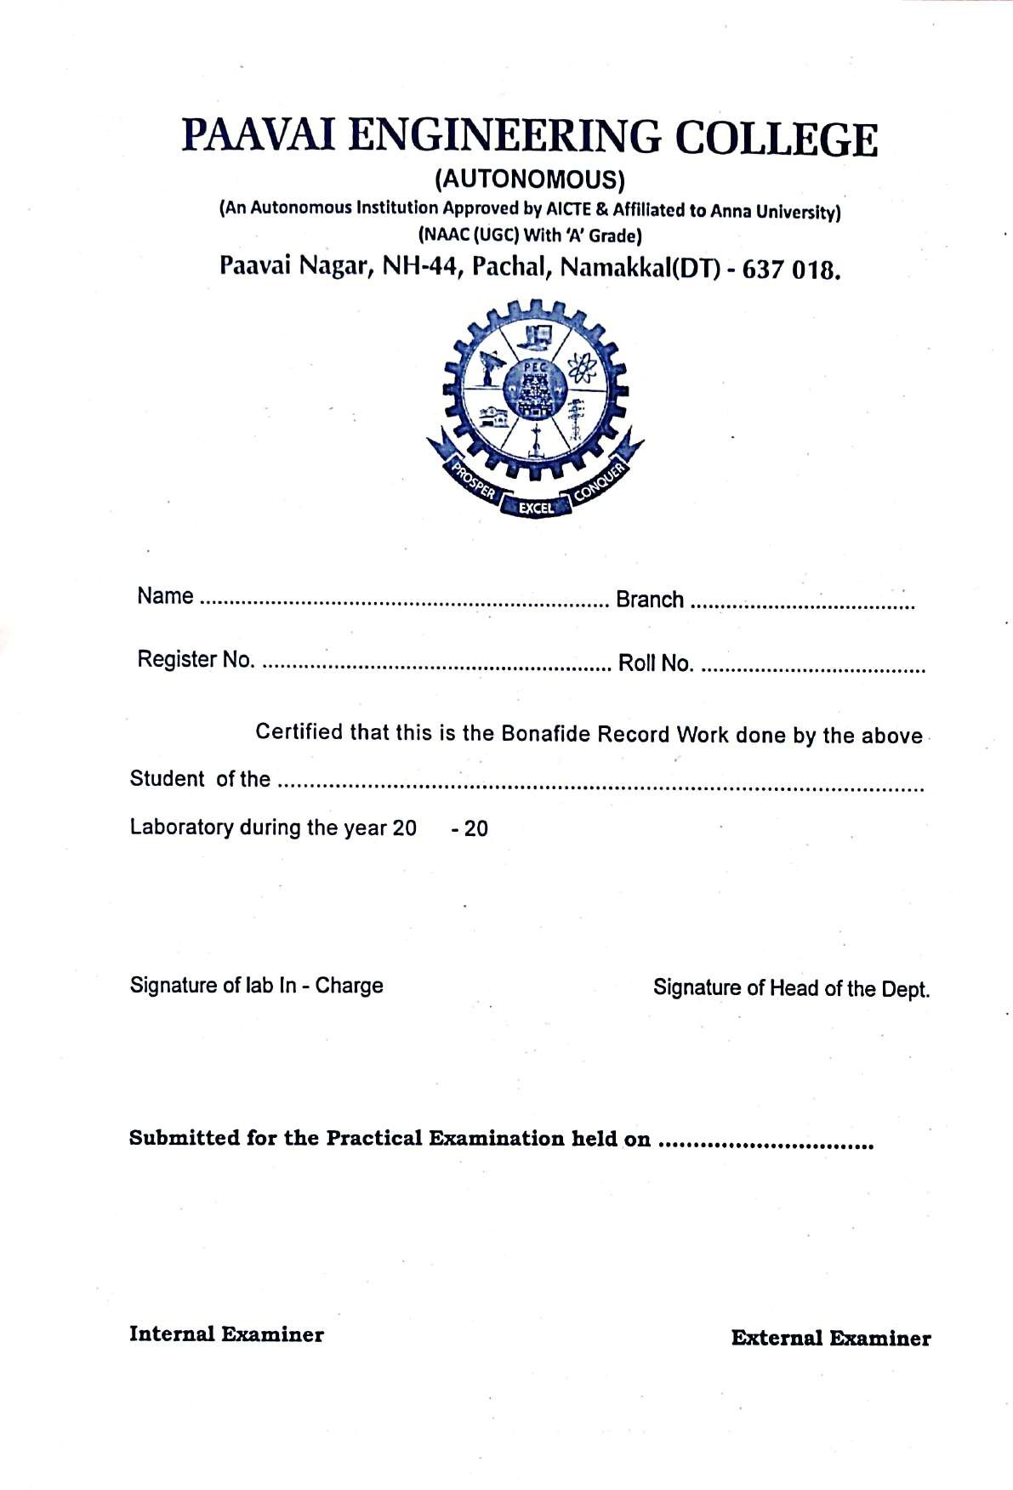

Ex.No: | Implementation of Python basic libraries (Statistics, Math, NumPy, SciPy) including the use of mathematical functions, array attributes and operations, matrix transformations, and determinant computation
Date:

Aim
To implement Python basic libraries such as Math, NumPy, SciPy and Statistics and demonstrate mathematical functions, array attributes, matrix operations, determinant calculation, and eigenvalues.

Algorithm
Step 1 : Start the program.
Step 2 : Import required Python libraries such as math, numpy, scipy, and statistics.
Step 3 : Implement mathematical functions using the math library.
Step 4 : Create arrays and perform operations using NumPy library.
Step 5 : Reshape arrays into different dimensions.
Step 6 : Generate matrices using NumPy.
Step 7 : Compute determinant using SciPy library.
Step 8 : Compute eigenvalues and eigenvectors using SciPy.
Step 9 : Display the results.
Step 10 : Stop the program.

Program 1

Mathematical Functions using Math Library
import math
x = 10.7
print("Floor value:", math.floor(x))
print("Ceil value:", math.ceil(x))
print("Square root:", math.sqrt(25))
print("Integer square root:", math.isqrt(16))
print("GCD:", math.gcd(20,30))

Output

Floor value: 10
Ceil value: 11
Square root: 5.0
Integer square root: 4
GCD: 10

Program 2

NumPy Array Attributes

import numpy as np
a = np.array([[1,2,3],[4,5,6]])
print("Array:\n",a)
print("Dimension:",a.ndim)
print("Shape:",a.shape)
print("Size:",a.size)

Output

Array:
[[1 2 3]
[4 5 6]]
Dimension: 2
Shape: (2,3)
Size: 6

Program 3

NumPy Array Operations

import numpy as np
a = np.array([10,20,30,40])
print("Sum:",a.sum())
print("Mean:",a.mean())
print("Sorted array:",np.sort(a))
print("Sin values:",np.sin(a))

Output

Sum: 100
Mean: 25.0
Sorted array: [10 20 30 40]
Sin values: [-0.54402111 0.91294525 -0.98803162 0.74511316]

Program 4

Reshape 1D List into 2D and 3D Matrix

import numpy as np
a = np.array([1,2,3,4,5,6,7,8])
b = a.reshape(2,4)
c = a.reshape(2,2,2)
print("2D Matrix:\n",b)
print("3D Matrix:\n",c)

Output

2D Matrix:
[[1 2 3 4]
[5 6 7 8]]
3D Matrix:
[[[1 2]
[3 4]]

[[5 6]
[7 8]]]

Program 5

Generate Random Matrix

import numpy as np
a = np.random.randint(1,10,(3,3))
print("Random Matrix:\n",a)

Output

Random Matrix:
[[9 8 5]
[9 1 6]
[4 3 9]]

Program 6

Determinant of Matrix using SciPy

import numpy as np

A = np.array([[2,3],[1,4]])

det = np.linalg.det(A)

print("Matrix:\n", A)
print("Determinant:", det)

Output

Matrix:
[[2 3]
[1 4]]
Determinant: 5.000000000000001

Program 7

Eigenvalues and Eigenvectors using SciPy

import numpy as np

A = np.array([[1, 2], [3, 4]])

value, vector = np.linalg.eig(A)

print("Eigen Values:", value)

print("Eigen Vectors:\n", vector)

Output

Eigen Values: [-0.37228132 5.37228132]
Eigen Vectors:
[[-0.82456484 -0.41597356]
[ 0.56576746 -0.90937671]]

.

PAAVAI ENGINEERING COLLEGE
(Autonomous)
DESCRIPTION | MAX. MARKS | MARKS AWARDED
Preparation& Conduction | 20
Observation  &Results | 10
Record Completion | 05
Viva Voce | 05
TOTAL | 40

Result:
Thus, the implementation of Python basic libraries such as Math, NumPy, SciPy and Statistics and their operations were successfully executed.

Ex.No:2 | Implementation of Python Libraries for ML. applications such as Pandas and Matplotlib.  to Create a Series using pandas and display,Access the index and the values of our Series, compare an array using NumPy with a series using pandas, Load datasets in a Data frame variable using pandas and Usage of different methods in Matplotlib.
Date:

Aim:

To implement Python libraries for Machine Learning applications such as Pandas and Matplotlib
to create and manipulate Series objects, compare NumPy arrays with Pandas Series, load datasets into DataFrames, and visualize data using different plotting methods.

Algorithm:
Step 1: Start the program
Step 2: Import the required libraries such as pandas, numpy, and matplotlib.
Step 3: Create a Series object using pandas and display it.
Step 4: Access the index and values of the Series.
Step 5: Compare a NumPy array with a pandas Series.
Step 6: Load a dataset into a DataFrame using pandas.
Step 7: Use Matplotlib functions to plot graphs.
Step 8: Display the results.
Step 9: Stop the program

Program 1

Create a Series using Pandas and Display

import pandas as pd
data = [10, 20, 30, 40, 50]
s = pd.Series(data)
print("Series:\n", s)

Output

Series:
0 10
1 20
2 30
3 40
4 50
dtype: int64

Program 2

Access Index and Values of a Series

import pandas as pd
data = [5, 10, 15, 20]
s = pd.Series(data)
print("Series:\n", s)
print("Index:", s.index)
print("Values:", s.values)

Output

Series:
0 5
1 10
2 15
3 20
dtype: int64
Index: RangeIndex(start=0, stop=4, step=1)
Values: [ 5 10 15 20]

Program 3

Compare NumPy Array with Pandas Series

import numpy as np
import pandas as pd
arr = np.array([1,2,3,4])
series = pd.Series([1,2,3,4])
print("NumPy Array:", arr)
print("Pandas Series:\n", series)

Output

NumPy Array: [1 2 3 4]
Pandas Series:
0 1
1 2
2 3
3 4
dtype: int64

Program 4

Load Dataset into DataFrame using Pandas

import pandas as pd
data = {
"Name": ["A", "B", "C"],
"Age": [21, 22, 23],
"Marks": [85, 90, 88]
}
df = pd.DataFrame(data)
print("DataFrame:\n", df)

Output

DataFrame:
Name Age Marks
0 A 21 85
1 B 22 90
2 C 23 88

Program 5

Plot Graph using Matplotlib

import matplotlib.pyplot as plt
x = [1,2,3,4]
y = [10,20,25,30]
plt.plot(x,y)
plt.title("Simple Line Graph")
plt.xlabel("X-axis")
plt.ylabel("Y-axis")
plt.show()

output

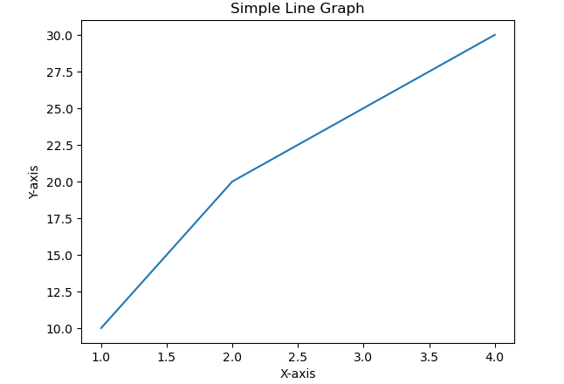

PAAVAI ENGINEERING COLLEGE
(Autonomous)
DESCRIPTION | MAX. MARKS | MARKS AWARDED
Preparation& Conduction | 20
Observation &Results | 10
Record Completion | 05
Viva Voce | 05
TOTAL | 40

RESULT:
Thus, the implementation of Python libraries for Machine Learning applications such as Pandas and Matplotlib was successfully performed
Ex.No:5 | WRITE A PYTHON PROGRAM TO IMPLEMENT SIMPLE LINEAR REGRESSION AND PLOT THE GRAPH
Date:

Aim:
To implement Simple Linear Regression using Python and plot the relationship between the independent variable and dependent variable using a graph.

Algorithm
Step 1: Start the program
Step 2: Import the required libraries such as numpy, matplotlib, and sklearn.
Step 3: Define the independent variable (X) and dependent variable (Y).
Step 4: Create the Linear Regression model.
Step 5: Train the model using the given data.
Step 6: Predict the output values using the model.
Step 7: Plot the regression line and data points using Matplotlib.
Step 8: Display the graph.
Step 9: Stop the program

Program

import numpy as np

import matplotlib.pyplot as plt

# Dataset

x = np.array([1,2,3,4,5])

y = np.array([2,4,5,4,5])

# Calculate mean

mean_x = np.mean(x)

mean_y = np.mean(y)

# Calculate slope (m)

m = np.sum((x-mean_x)*(y-mean_y)) / np.sum((x-mean_x)**2)

# Calculate intercept (b)

b = mean_y - m*mean_x

# Regression line

y_pred = m*x + b

# Plot original data

plt.scatter(x,y,color='blue')

# Plot regression line

plt.plot(x,y_pred,color='red')

plt.title("Simple Linear Regression")

plt.xlabel("X values")

plt.ylabel("Y values")

plt.show()

print("Slope:",m)

print("Intercept:",b)

output

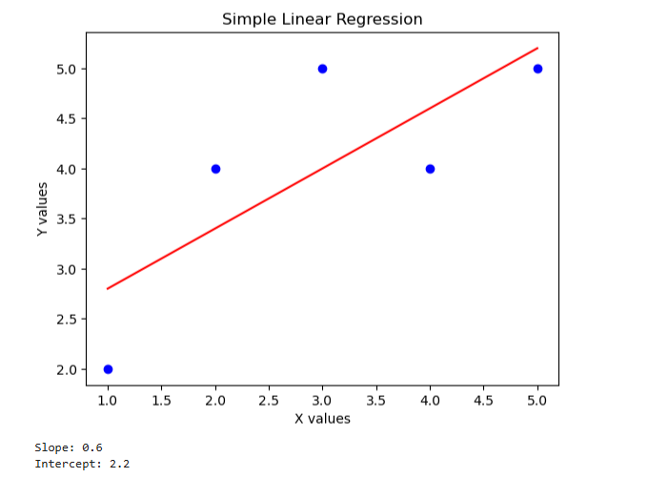

PAAVAI ENGINEERING COLLEGE
(Autonomous)
DESCRIPTION | MAX. MARKS | MARKS AWARDED
Preparation& Conduction | 20
Observation &Results | 10
Record Completion | 05
Viva Voce | 05
TOTAL | 40

RESULT:

Thus, the Simple Linear Regression model was implemented successfully and the regression
graph was plotted using Python.

Ex.No:7 | Write a Python program to implement K-Means Clustering Algorithm for different K values
Date:

Aim:
To implement the K-Means Clustering Algorithm using Python and analyze clustering
results for different K values.
Algorithm
Step 1: Start the program
Step 2: Import the required libraries such as NumPy and Matplotlib.
Step 3: Create or load the dataset.
Step 4: Select the number of clusters K.
Step 5: Initialize K centroids randomly from the dataset.
Step 6: Calculate the distance between each data point and centroid.
Step 7: Assign each data point to the nearest centroid to form clusters.
Step 8: Update the centroid by calculating the mean of all points in the cluster.
Step 9: Repeat steps 6–8 until centroids do not change.
Step 10: Display the clusters and centroids using a graph.
Step 11: Repeat the process for different K values.
Step 12: Stop the program

Program

import numpy as np
import matplotlib.pyplot as plt

# Sample dataset
X = np.array([
[1,2],[1.5,1.8],[2,2.2],
[8,8],[8.5,7.5],[9,8],
[5,5],[6,5.5],[6.5,6],[7,5]
])

# K-Means function
def kmeans(X, k, max_iter=100):

# Initialize centroids randomly
np.random.seed(0)
centroids = X[np.random.choice(len(X), k, replace=False)]

for _ in range(max_iter):

clusters = [[] for _ in range(k)]

# Assign points to nearest centroid
for point in X:
distances = [np.linalg.norm(point - centroid) for centroid in centroids]
cluster_index = np.argmin(distances)
clusters[cluster_index].append(point)

# Update centroids
new_centroids = []
for cluster in clusters:
new_centroids.append(np.mean(cluster, axis=0))

new_centroids = np.array(new_centroids)

# Check convergence
if np.all(centroids == new_centroids):
break

centroids = new_centroids

return clusters, centroids

# Different K values
K_values = [2,3,4]

for k in K_values:

clusters, centroids = kmeans(X, k)

print("K =", k)
print("Centroids:\n", centroids)

# Plot clusters
plt.figure()

for cluster in clusters:
cluster = np.array(cluster)
plt.scatter(cluster[:,0], cluster[:,1])

plt.scatter(centroids[:,0], centroids[:,1], color='black', marker='X', s=200)

plt.title("K-Means Clustering (K = {})".format(k))
plt.xlabel("Feature 1")
plt.ylabel("Feature 2")
plt.show()

output

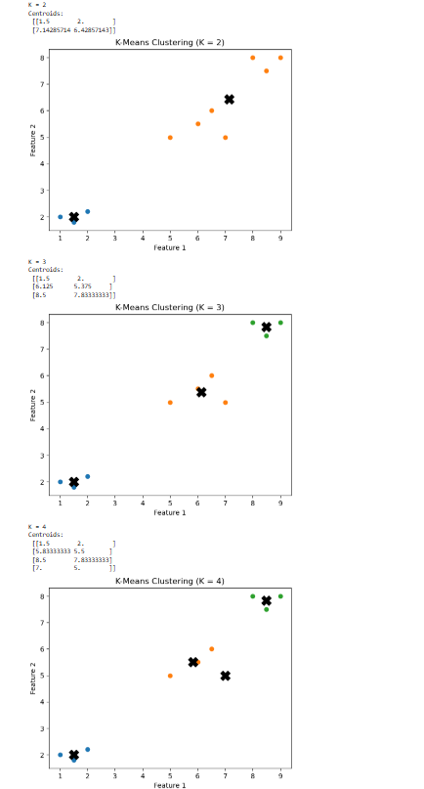

PAAVAI ENGINEERING COLLEGE
(Autonomous)
DESCRIPTION | MAX. MARKS | MARKS AWARDED
Preparation& Conduction | 20
Observation  &Results | 10
Record Completion | 05
Viva Voce | 05
TOTAL | 40

RESULT:

Thus, the K-Means Clustering Algorithm was successfully implemented using Python and clustering results
were obtained for different K values.

Ex.No:10 | Write a Python program to implement Intrusion Detection System using Support Vector Machine (SVM)
Date:

Aim:

To develop an Intrusion Detection System (IDS) using the Support Vector Machine (SVM) algorithm

in Python to classify network activities as normal or intrusion.

Algorithm

Step 1: Start the program
Step 2: Import the required libraries such as NumPy and Matplotlib.
Step 3: Prepare a dataset containing network traffic features and labels (normal or attack).
Step 4: Separate the dataset into input features (X) and target labels (Y).
Step 5: Initialize the SVM classifier.
Step 6: Train the SVM model using the training dataset.
Step 7: Use the trained model to predict the class of test data.
Step 8: Compare predicted values with actual values.
Step 9: Calculate the accuracy of the model.
Step 10: Display the prediction results.
Step 11: Stop the program
Program
import numpy as np

# Sample dataset
# Features: [packet_size, login_attempts]
X = np.array([
[100,1],
[200,2],
[150,1],
[300,4],
[350,5],
[400,6]
])

# Labels: 0 = Normal, 1 = Intrusion
Y = np.array([0,0,0,1,1,1])

# Simple SVM implementation
def train_svm(X, Y, lr=0.001, lambda_param=0.01, n_iters=1000):

n_samples, n_features = X.shape
w = np.zeros(n_features)
b = 0

for _ in range(n_iters):
for idx, x_i in enumerate(X):
condition = Y[idx] * (np.dot(x_i, w) - b) >= 1

if condition:
w -= lr * (2 * lambda_param * w)
else:
w -= lr * (2 * lambda_param * w - np.dot(x_i, Y[idx]))
b -= lr * Y[idx]

return w, b

# Convert labels to -1 and 1
Y_svm = np.where(Y == 0, -1, 1)

# Train model
w, b = train_svm(X, Y_svm)

# Prediction function
def predict(X, w, b):
approx = np.dot(X, w) - b
return np.sign(approx)

# Test prediction
predictions = predict(X, w, b)

print("Predictions:", predictions)

Output

Predictions: [-1 -1 -1 1 1 1]

PAAVAI ENGINEERING COLLEGE
(Autonomous)
DESCRIPTION | MAX. MARKS | MARKS AWARDED
Preparation& Conduction | 20
Observation  &Results | 10
Record Completion | 05
Viva Voce | 05
TOTAL | 40

RESULT:
Thus, the Intrusion Detection System using Support Vector Machine (SVM) was successfully
implemented in Python and network traffic was classified as normal or intrusion

